**Hands On 2: RESTful Web Service resource naming guidelines**   
  
**Country.java**

package com.cognizant.orm_learn.model;

import jakarta.persistence.Entity;

import jakarta.persistence.Id;

@Entity

public class Country {

@Id

private String code;

private String name;

public Country() {

}

public Country(String code, String name) {

this.code = code;

this.name = name;

}

public String getCode() {

return code;

}

public void setCode(String code) {

this.code = code;

}

public String getName() {

return name;

}

public void setName(String name) {

this.name = name;

}

}

**CountryRepository**

package com.cognizant.orm_learn.repository;

import com.cognizant.orm_learn.model.Country;

import org.springframework.data.jpa.repository.JpaRepository;

public interface CountryRepository extends JpaRepository<Country, String> {

}

**CountryController**

package com.cognizant.orm_learn.controller;

import com.cognizant.orm_learn.model.Country;

import com.cognizant.orm_learn.service.CountryService;

import org.springframework.beans.factory.annotation.Autowired;

import org.springframework.web.bind.annotation.*;

import java.util.List;

@RestController

@RequestMapping("/countries") // Class level: plural resource name

public class CountryController {

@Autowired

private CountryService countryService;

@GetMapping

public List<Country> getAllCountries() {

return countryService.getAllCountries();

}

@GetMapping("/{code}")

public Country getCountry(@PathVariable String code) {

return countryService.getCountry(code);

}

@PostMapping

public void addCountry(@RequestBody Country country) {

countryService.addCountry(country);

}

@PutMapping

public void updateCountry(@RequestBody Country country) {

countryService.updateCountry(country);

}

@DeleteMapping("/{code}")

public void deleteCountry(@PathVariable String code) {

countryService.deleteCountry(code);

}

}

**Output**

**Get all countries**

**Url:** GET <http://localhost:8080/countries>

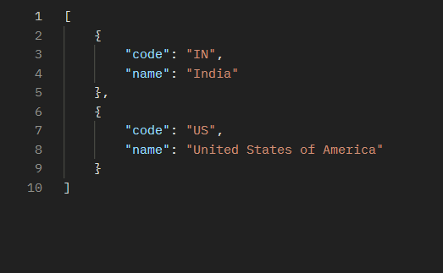

**Get specific countries**

**Url: GET** <http://localhost:8080/countries/IN>

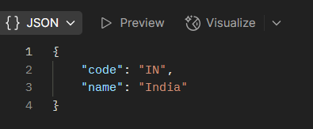

**Create new country**

**Url:** POST <http://localhost:8080/countries>

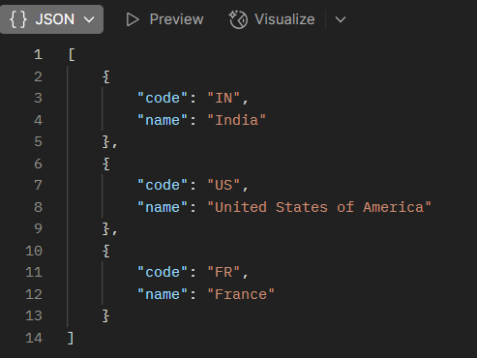

**Update a country**

**Url:** PUT <http://localhost:8080/countries>

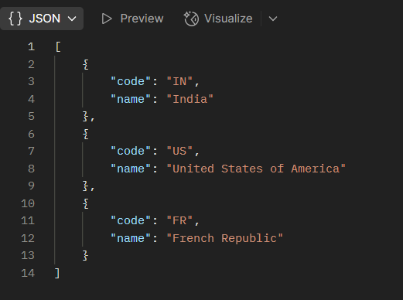

**Delete a country**

**Url:** DELETE <http://localhost:8080/countries/FR>

